Automated Itinerary Planning
Project Progress Report
(Covering Period: June 2017 to November 2017)

By

Minal Bhandari (149111757)
Siddharth Bhadri (149111620)
Suyash Khemka (149111136)



Information Technology Department

MANIPAL UNIVERSITY JAIPUR
JAIPUR-303007
RAJASTHAN, INDIA

November 2017

Department of Information Technology,
Manipal University Jaipur,
Jaipur – 303007 (Rajasthan), India

Date: 21 Nov 2017

CERTIFICATE

This is to certify that the project titled Automated Itinerary Planning is a record of the bonafide work done by Minal Bhandari (Reg No:149111757), Siddharth Bhadri (Reg No:149111620) and Suyash Khemka (Reg No:149111136), submitted in partial fulfilment of the requirements for the award of the Degree of Bachelor of Technology (B.Tech) in Information Technology of Manipal University Jaipur, during the academic year 2017-18.

Mr. Jigyasu Nema and Mrs. Kuntal Gaur,
Department of Information Technology,
Manipal University Jaipur

ABSTRACT

Most of the people love to travel. They visit popular tourist destinations such as monuments, natural parks, entertainment spots, etc. and plan a trip every once in a while to relax, explore new things or simply for shopping and quality time. But before leaving for the trip, it is important to have a plan which will cover all the details of the trip such as visiting which destination at what time and in what sequence. Creating this plan efficiently is not easy as the user has to first do a full research of the area he has to visit and then consider a lot of factors such as distance and visiting timings. Thus automated itinerary planning does all this work and present the user with a plan which satisfies the choices of the customer.

First, the pink city Jaipur was selected and the details of all the popular tourist destinations in Jaipur were collected and stored. User’s preferred choice of places and free slot timings were taken as input and a suitable itineraries were developed and presents as output. A very popular evolutionary algorithm called ant colony optimization was used to create itineraries satisfying the required constraints.

The methodology that has been used is iterative waterfall model. First the problem was identified and checked whether it was feasible to implement. Then requirements were analyzed and gathered. A user friendly webpage was designed for users where they can fill their choices and available slots. After analysis and designing stage, coding was done to implement ant colony optimization for generation of itinerary. Lastly the results were tested if coming appropriate.

Thus, the user is presented with few efficiently planned itineraries and he can choose whichever he likes best. This project is beneficial to learn how a real time problem is solved keeping in mind various constraints. The various problems faced by man in day to day life while planning trips were analyzed and solutions were devised to solve them. By using this itinerary his time will be efficiently utilized and he will enjoy his trip.

LIST OF TABLES

Table No | Table Title | Page No
4.1 | Tourist Destinations in Jaipur | 9
5.1 | Time Line Chart | 10

LIST OF FIGURES

Figure No | Figure Title | Page No
1.1 | Choosing path wisely saves time as well as cost | 1
 | Visiting most popular destinations | 2
1.3 | Visiting user’s preferred destinations | 3
1.4 | Visiting user’s specified destination at a specific time | 3
2.1 | Google Geocoding API for Manipal University Jaipur | 6
3.1 | Use Case Diagram | 7
3.2 | ER Diagram | 8

CONTENTS

Abstract i
List of tables ii
List of figures iii

Chapter 1 Introduction
  - Introduction 1
  - Motivation 1
  - Project Statement 2
  - Objective 2
  - Organization of Report 4

Chapter 2 Background Overview
2.1 Conceptual Overview 4
2.2 Technologies Involved 5

Chapter 3 Methodology
3.1 Detailed Methodology 6
3.2 Use Case Diagram 7
3.3 Entity Relationship Diagram 8

Chapter 4 Implementation and Results
4.1 Implementation and Algorithm 9

Chapter 5 Future Work and Conclusion
5.1 Time Line Chart 10
5.2 Conclusion 11
5.3 Future Work 11

References 12

Chapter 1

1.1 Introduction

Today most of the people love to travel but traveling is not as simple as choosing destinations randomly and visiting them one by one. What we need is an itinerary which is a plan that displays how you will get from one point to another and when you will be at each point. A travel itinerary is a schedule of events relating to planned travel, generally including destinations to be visited at specified times.

A travel itinerary should effectively manage your travel time to certain numerous attractions while at the same time considering all constraints and unforeseen circumstances such as traffic, opening and closing timings of a destination. Also the itinerary should select each customer’s preferred destinations instead of picking up the most popular destinations as ultimately every person has different tastes and each customer should be satisfied with his own itinerary.

In this project, an itinerary plan is generated based on the user entered choices of places. The user specifies his available free slots in a day, the type of destinations such as monuments, nature or arts, the type of food such as Indian, Mexican, Italian or Chinese, locations from where he wants to start and end the trip. After considering all these choices, we prepare a plan best suited for the customer so that the customer can travel with a proper plan and do not waste his time and resources.

1.2 Motivation

Consider the following scenarios:

- Suppose you have 3 destinations to visit and you choose them randomly one by one. Two of them lie on the same route and one on different.

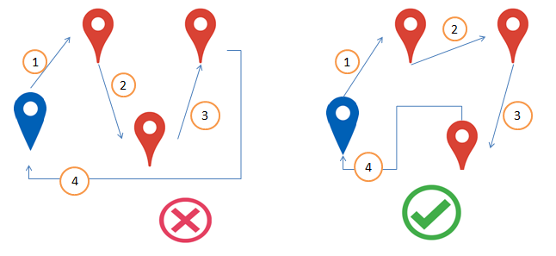
Figure 1.1 Choosing path wisely saves time as well as cost

- Suppose you reach a destination at 6pm but realise that the visiting hours of that destination is from 3pm to 4pm.
These are some problems which we may face if we travel without a plan. Thus it is important to have an itinerary which saves our time and cost and at the same time considers the visiting hours of destinations, areas currently closed due to construction, etc. which may affect our plan.

Creating an efficient and economic trip plan is the most annoying job for a traveler. Although some travel agencies can provide predefined itineraries, they are not tailored for each specific customer.
The project will generate an itinerary suitable to customer’s requirements.

1.3 Project Statement

The project aims to design a detailed day-by-day itinerary to travel a city (Jaipur) while considering time, cost, user’s preferences, user’s available time slots, visiting hours of destinations and traffic. Thus by making use of automated planning techniques, the user will be presented with the most optimum 2-3 itinerary plans satisfying all the constraints required.

1.4 Objective

The aim of the project is to design an itinerary that considers all the constraints such as time, cost as well as user’s preferred choices. A high rated place may not be gorgeous for the users who have visited the city for several periods or have incomplete time economic understanding. The user may instead want to go to a low rated place as it will be new for him. That is why having a user preferred itinerary is more useful.

Consider the following cases:

CASE 1: Visiting most popular destinations

Lets say the user has only one day to travel (11am-6pm) and wants to visit as many popular destinations as possible. Then our application will create 2-3 plans according to which the user can visit about 3-5 popular destinations.

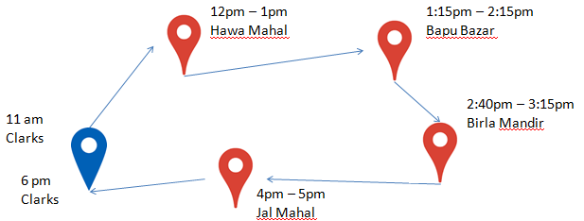

Figure 1.2 Visiting most popular destinations
CASE 2:Visiting user’s preferred destinations

Lets say the user has only one day to travel (11am-6pm) and wants to visit Hawa Mahal, Amer Fort and Jal Mahal. Then our application will create a plan keeping in mind the visiting hours of each destination and the distance covered.

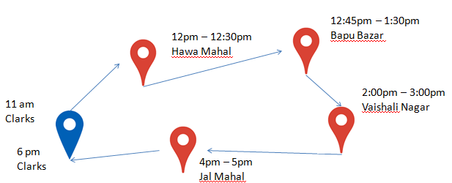

Figure 1.3 Visiting user’s preferred destinations

CASE 3: Visiting most popular destinations & a user’s specified destination at a specific time.

Lets say the user has only one day (11am-6pm) to travel and wants to visit as many popular destinations as possible. But the user wants to go to Vaishali Nagar between 2-3 pm. Then our application will create 2-3 plans satisfying all the requirements.

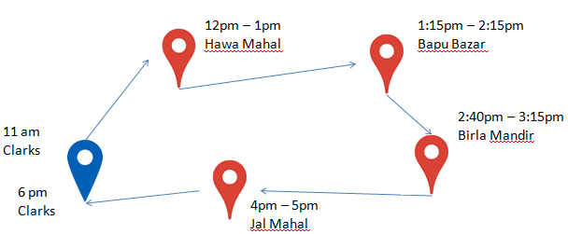

Figure 1.4 Visiting user’s specified destination at a specific time

CASE 4: Visiting most popular destinations & dynamically changing plan due to heavy traffic.

Lets say the user has only one day to travel (11am-pm) and wants to visit as many popular destinations as possible. But during the journey the application finds that due to an accident the bapu bazar area has very high traffic. Then the application will dynamically change the route amidst the journey and instead of visiting bapu bazar, the itinerary will include another popular destination nearby.

These cases show how an itinerary will consider all worse cases and presents the most suitable plan.
1.5 Organization of Report

The project report first describes the problem faced and its applicability in real life, what motivated us to work on this problem and what all aspects are being covered. Then the report discusses the concepts and algorithm used. It also contains the use case and entity relationship diagram of the project. Lastly, the conclusion and future aspects of the project have also been given.

Chapter 2

2.1 Conceptual Overview

Ant Colony Optimization^{[7]}
- In the natural world, ants of some species (initially) wander randomly, and upon finding food return to their colony while laying down pheromone trails.
- If other ants find such a path, they are likely not to keep travelling at random, but instead to follow the trail, returning and reinforcing it if they eventually find food. Over time, however, the pheromone trail starts to evaporate, thus reducing its attractive strength.
- The more time it takes for an ant to travel down the path and back again, the more time the pheromones have to evaporate.
- A short path, by comparison, gets marched over more frequently, and thus the pheromone density becomes higher on shorter paths than longer ones.
- Pheromone evaporation also has the advantage of avoiding the convergence to a locally optimal solution.
- If there were no evaporation at all, the paths chosen by the first ants would tend to be excessively attractive to the following ones. In that case, the exploration of the solution space would be constrained.
- The influence of pheromone evaporation in real ant systems is unclear, but it is very important in artificial systems.

The overall result is that when one ant finds a good (i.e., short) path from the colony to a food source, other ants are more likely to follow that path, and positive feedback eventually leads to all the ants following a single path. The idea of the ant colony algorithm is to mimic this behavior with "simulated ants" walking around the graph representing the problem to solve.

Using ant colony optimization, we can create an initial set of paths and whichever path satisfies all the time constrains and will visit maximum places will leave more pheromone. Other ants will start taking that direction and will start diverging at different points trying to find a more optimized path. And after a certain number of iterations we will find a few good routes and project the best 2-5 routes to the user.

Nearest Neighbor Technique
- The nearest neighbor algorithm was one of the first algorithms used to determine a solution to the travelling salesman problem.
- In it, the salesman starts at a random city and repeatedly visits the nearest city until all have been visited. It quickly yields a short tour, but usually not the optimal one.
- During lunchtime, using the user’s current location, nearby restaurants will be suggested and after lunchtime Ant Colony Optimization will be continued.
2.2 Technologies involved

Bootstrap^{[6]}
- Bootstrap is an open source toolkit for developing with HTML, CSS, and JS. Quickly prototype your ideas or build your entire app with our Sass variables and mixins, responsive grid system, extensive prebuilt components, and powerful plugins built on jQuery.
- Bootstrap is modular and consists of a series of less that implement the various components of the toolkit. These stylesheets are generally compiled into a bundle and included in web pages, but individual components can be included or removed. Bootstrap provides a number of configuration variables that control things such as color and padding of various components.
- Responsive design makes it possible for a web page or app to detect the visitor’s screen size and orientation and automatically adapt the display accordingly; the mobile first approach assumes that smartphones, tablets and task-specific mobile apps are employees' primary tools for getting work done and addresses the requirements of those technologies in design.
- Bootstrap includes user interface components, layouts and JS tools along with the framework for implementation. The software is available precompiled or as source code.
- In the physical world, a bootstrap is a small strap or loop at the back of a leather boot that enables you to pull the entire boot on and in general usage, bootstrapping is the leveraging of a small initial effort into something larger and more significant.
- There is also a common expression, "pulling yourself up by your own bootstraps," meaning to leverage yourself to success from a small beginning.
MySQL
- MySQL is the most popular Open Source Relational SQL Database Management System. MySQL is one of the best RDBMS being used for developing various web-based software applications. MySQL is developed, marketed and supported by MySQL AB, which is a Swedish company.
- MySQL runs on virtually all platforms, including Linux, UNIX, and Windows. Although it can be used in a wide range of applications, MySQL is most often associated with web-based applications and online publishing and is an important component of an open source enterprise stack called LAMP.
- LAMP is a Web development platform that uses Linux as the operating system, Apache as the Web server, MySQL as the relational database management system and PHP as the object-oriented scripting language. (Sometimes Perl or Python is used instead of PHP.)
- MySQL, which was originally conceived by the Swedish company MySQL AB, was acquired by Sun Microsystems in 2008 and then by Oracle when it bought Sun in 2010. Developers can still use MySQL under the GNU General Public License (GPL), but enterprises must obtain a commercial license from Oracle.
Geocoding API^{[5]}
- The Google Maps APIs give developers several ways of embedding Google Maps into web pages or retrieving data from Google Maps, and allow for either simple use or extensive customization.
- There are several API offerings: It is the process of converting into geographic coordinates, which you can use to place markers on a map, or position the map.
- The geographic coordinates representing locations often vary greatly in positional accuracy. Examples include building centroids, land parcels, street addresses, postal code centroids (e.g. ZIP codes, CEDEX), and Administrative Boundary Centroids.
- Geocoded locations are useful in many GIS analysis, cartography, decision making workflow, transaction mash-up, or injected into larger business processes.
- On the web, geocoding is used in services like routing and local search. Geocoding, along with GPS provides location data for geotagging media, such as photographs or RSS items.
- Reverse geocoding is the process of converting geographic coordinates into a human-readable address.
- You can also use the Google Maps Geocoding API to find the address for a given place ID. Client libraries make developing with the Google Maps web service APIs easier by providing simple, native implementations of common tasks, such as authentication, request throttling and automatic retry. The Google Maps Geocoding API is available in the Java Client, Python Client, Go Client and Node.js Client for Google Maps Services.

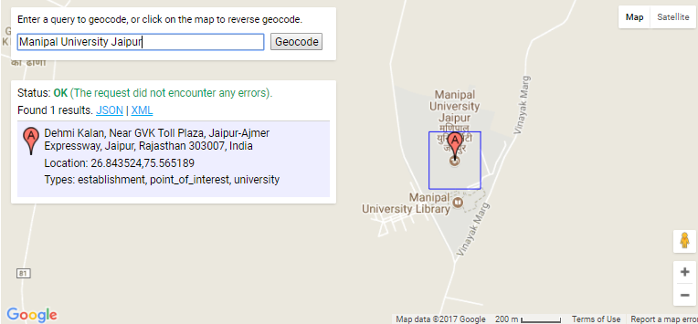

Figure 2.1 Google Geocoding API for Manipal University Jaipur

Chapter 3

3.1 Detailed Methodology

The methodology that has been used to develop the project is iterative waterfall model. First the problem of planning an efficient itinerary was identified. The problems faced by men in daily life while going on trips due to inefficient planning were analyzed. Then the entities involved and their attributes were considered and designing phase was completed. Then solutions were devised and implemented using the most suitable algorithm. The results were then tested and it was seen that the objective of the project was completed. Thus, the user will get a time and cost efficient itinerary planned in just a few seconds.

3.2 Use Case Diagram

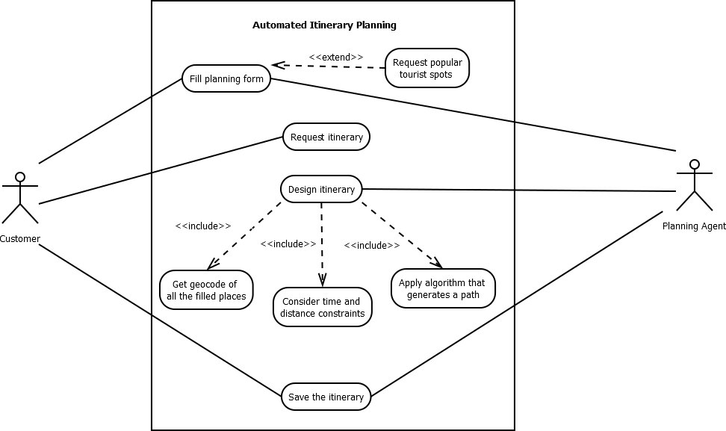

Figure 3.1 Use Case Diagram

3.3 Entity Relationship Diagram

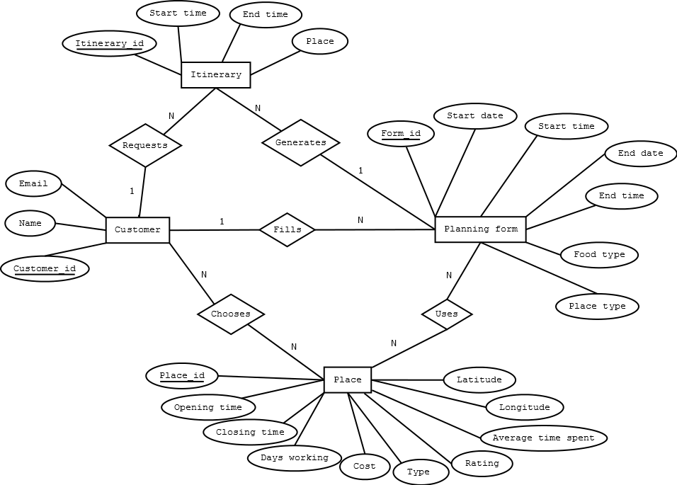

Figure 3.2 ER Diagram

Chapter 4

4.1 Implementation and Algorithm

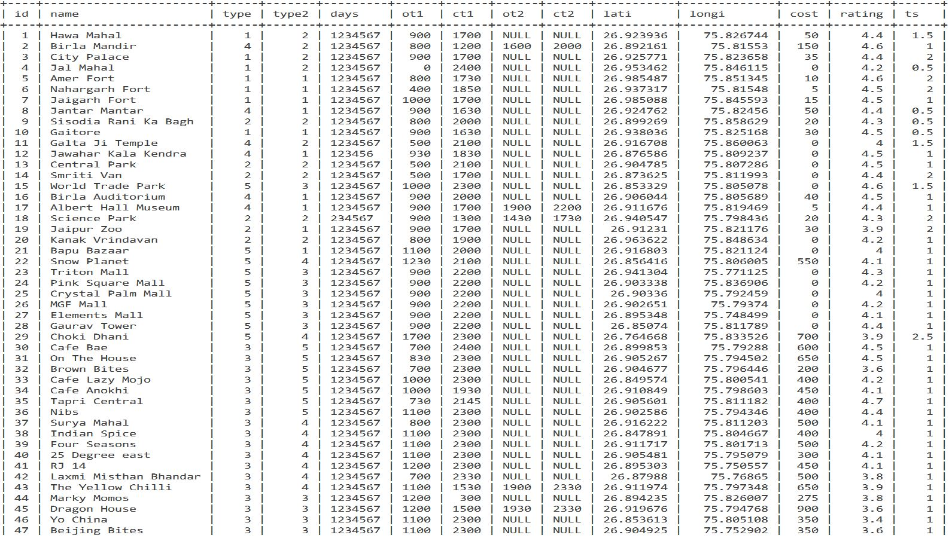

Table 4.1 Tourist Destinations in Jaipur

Algorithm

Fetch id’s and and geocodes of places of interest of the user.
Store the number of id’s in n
Get start-time, end-time, start-position, end-position
Trip[1000][20]
Value[1000]
For i=1 to 1000
Time =starttime, flag=0,currentloc=start_loc
While (flag==0)
{count =0 ,x=0,y=0;
While(count<10)
{
Count++
X=rand%n
If x already not visited
{
If(time for goinf to x + avg time spent at x + going to end loc <end time)
{
Trip[i][y++]=x;
Current loc =geocode(x);
Break;
}
}
}
If(count==10)
{
Trip[i][x]=end loc;
Flag=1;
}
Repeat the below process for 100 times
Calculate value of each route such that for each route.
(4.5)->(5.0) rating -> 18 points
(4.0)->(4.49) rating -> 12 points
(3.6)->(3.99) rating -> 8 points
(3.0)->(3.49) rating -> 6 points
Find the best 10 routes
And divide the next 1000 ants in the following number
175,150,125,125,100,100,75,50,45,45

First 175 threads will start from the best path of the previous iteration and each will diverge at any random location and complete the path and return. This process will continue for 100-150 times. At the end the best 5 itinerary will be displayed to the user.
If user wants to remove a location from itinerary then the place before that will be chosen as starting point and rest all parameters will be same and the progress will be same.

To provide dynamism during the travel time, suppose a user spends extra time at a location or even if he doesn’t , his future trip will be verified or completed depending upon whether the further trip can still be accomplished depending on real time data from google maps and if it cannot be accomplished then new itinerary will be provided.

Chapter 5

5.1 Time Line Chart

Approximate time 6 months
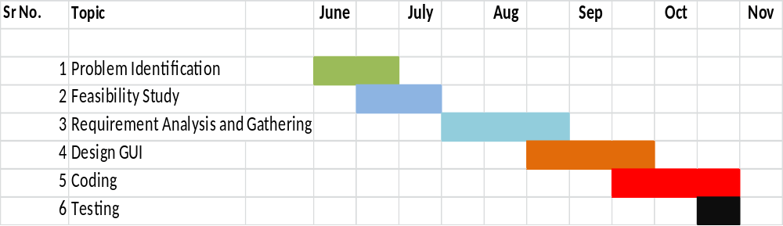 Table 5.1 Time Line Chart

5.2 Conclusion

The project designs an itinerary containing a list of places to be visited at given timings. This itinerary is designed using ant colony optimization algorithm which takes into account the time slots in which user is available, user’s preferred type of destinations, the distance between various places, the opening and closing timings of tourist spots and ratings of different destinations. It is difficult for a person to consider all these factors simultaneously for a comfortable trip. This project makes the job easier and faster so that the user can enjoy his trip.

5.3 Future Work

- Some places are mostly preferred by people to visit in the evening such as Birla Mandir and thus a person would most probably like to visit Birla Mandir in evening. But the itinerary generation has not been done considering this factor because of insufficient data available regarding the same. Thus popular visiting hours of places can be collected and thus factored while designing the itinerary.
- This project only covers one city Jaipur. It can be extended to more cities and further to an entire country.
- The itinerary can be dynamic. Suppose after an itinerary is created and user starts travelling as per the created plan. But after reaching a specific location defined in the itinerary, the user spends more than the average time spent at that place. Then he will specify the time at which he left that destination and then the rest of the itinerary will be changed accordingly.

REFERENCES

- S.B. Roy, G. Das, S. Amer-Yahia, and C. Yu, “Interactive Itinerary Planning,” Proc. IEEE 27th Int’l Conf. Data Eng. (ICDE), pp. 15-26, 2011.

[2] Kwan Hui Lim, “Recommending and Planning Trip Itineraries for Individual Travellers and Groups of Tourists”, Department of Computing and Information Systems, The University of Melbourne, Australia, 2016

[3] Popular tourist spots in Jaipur, tripadvisor, “https://www.tripadvisor.in/”

[4] Jaipur tourism, Ixigo, “https://www.ixigo.com/”

[5] Google Maps APIs, “https://developers.google.com/maps/”

[6] Bootstrap, “http://getbootstrap.com/”

[7] Ant Colony Optimisation, ” https://en.wikipedia.org/wiki/Ant_colony_optimization_algorithms”

[8] Itinerary Planner, inspirock, “https://www.inspirock.com/”

